Error #1: Semicolon missing

Input:

var x, y

begin

x := y + 56;

end.

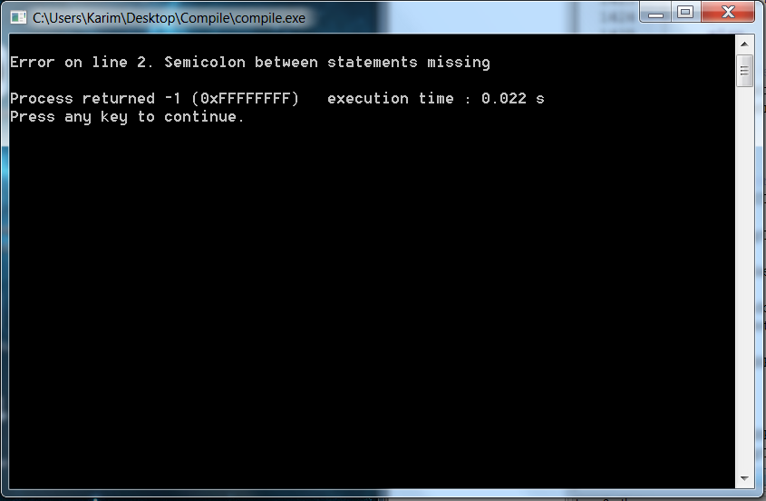

Error #2: Period Missing

Input:

var x, y;

begin

x := y + 56;

end

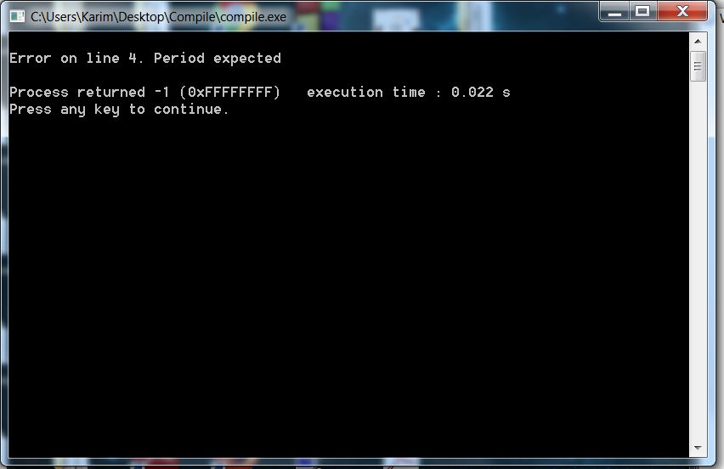

Error #3: Duplicate var or const

Input:

var x, y;

var x;

begin

x := y + 56;

end.

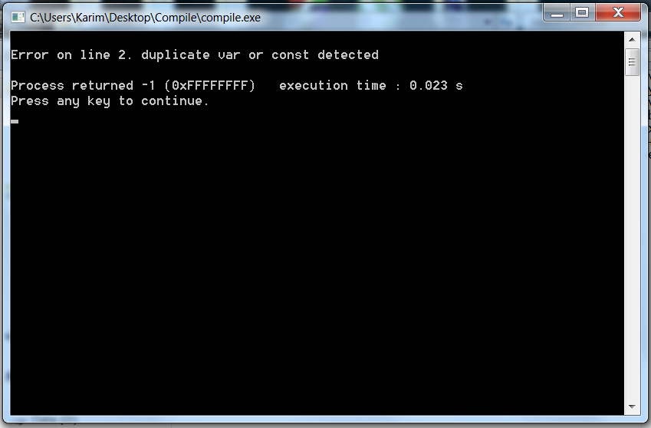

Error #4: Invalid symbol

Input:

var x, y;@

begin

x := y + 56;

end.

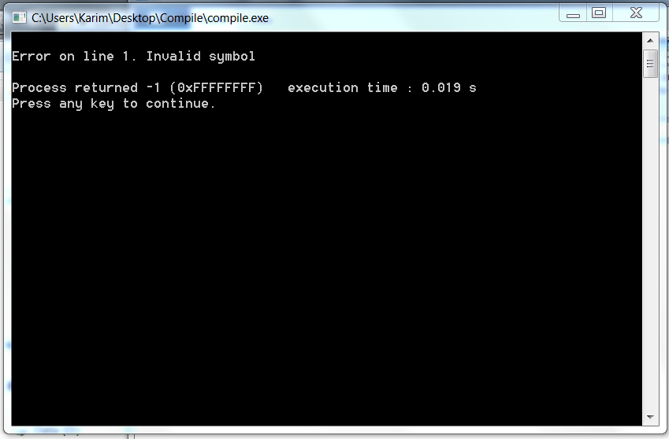

Error #5: = instead of :=

Input:

var x, y;

begin

x = y + 56;

end.

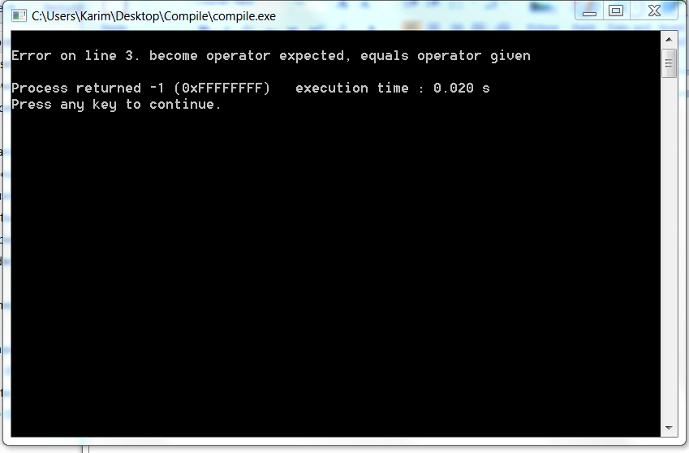

Error #6: Variable used without being declared

Input:

var x;

begin

x := y + 56;

end.

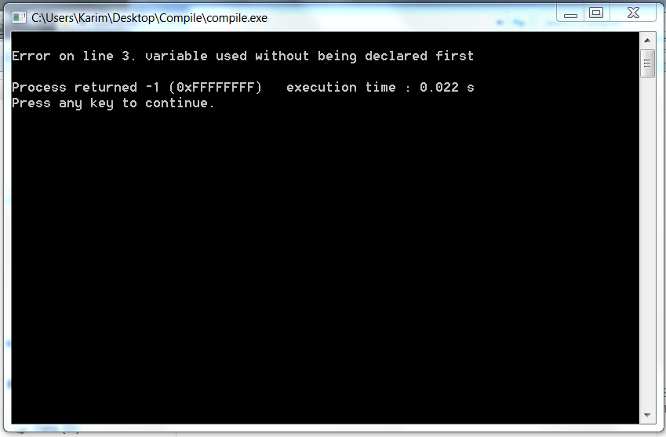

Error #7: Number was too long

Input:

var x, y;

begin

x := y + 5680989089089890;

end.

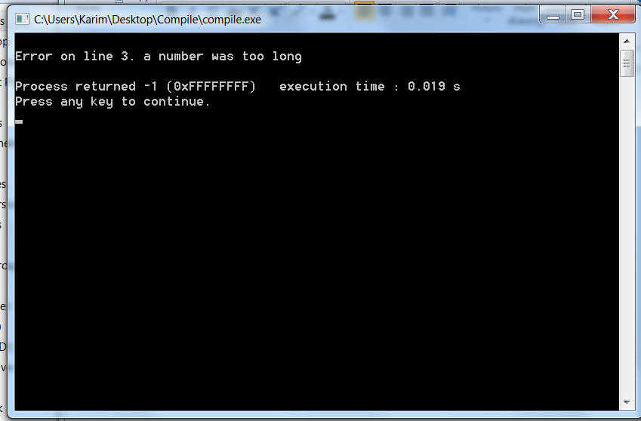

Error #8: Identifier too long

Input:

var x, yankedoodledoo;

begin

x := y + 56;

end.

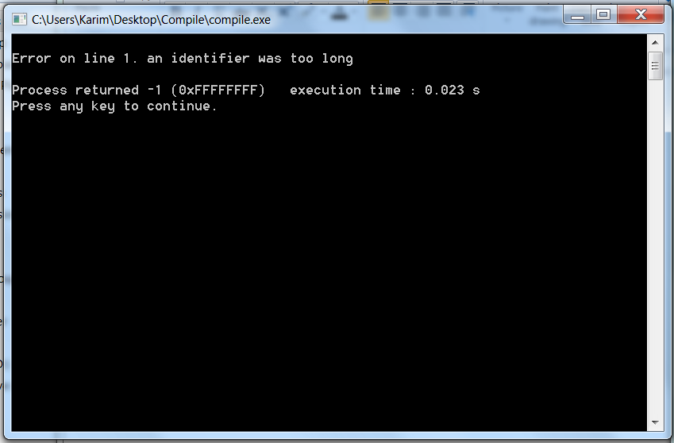

Error #9: right parenthesis missing

Input:

var x, y;

begin

x := (y + 56;

end.

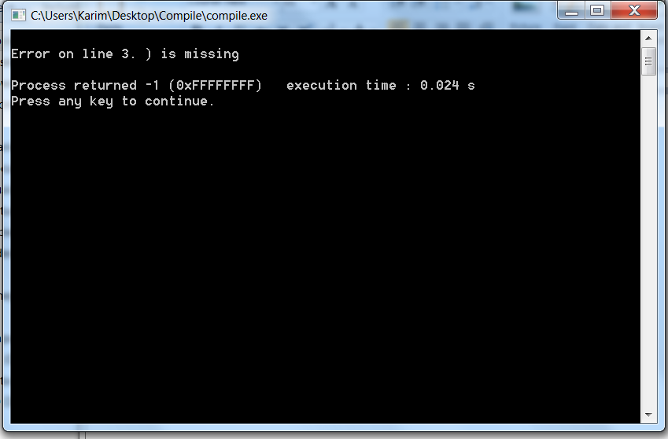

Error #10: semicolon or comma missing

Input:

var x y;

begin

x := y + 56;

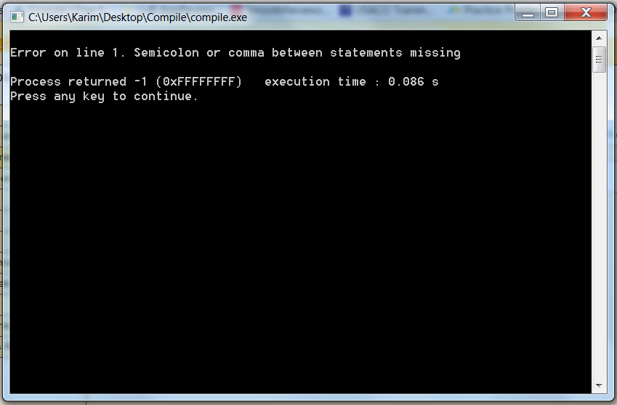end.